Name: _____________________________________________________ Date: _________________ Period: _______
Lesson 1.2.7 Problems 1-124 to 1-129
1-124. What is the probability of getting either blue or green on a spinner that is 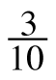 green and 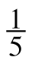 blue? Show your work.

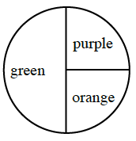
1-125. If you were to spin the spinner below, what would be the probability of landing on green or purple? Explain how you know.

1-126. Find a value for x that will make each of the following equations true.
a. x + 8 = 21 b. x – 32 = 55 c. 3x = 54 d. 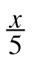= 10

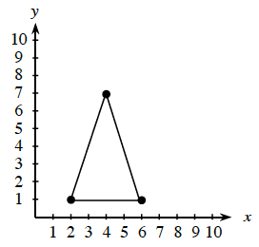
1-127. Locate the coordinates of the three highlighted points on the graph of the triangle below and write them as ordered pairs ( x, y ).

1-128. Draw an example of each of the following shapes. If you need help, click each one for the glossary information.
a. rectangle b. square c. parallelogram

d. trapezoid e. scalene triangle f. right triangle

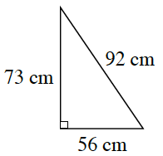
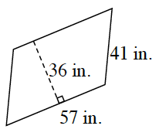
1-129. Find the area and perimeter of each figure below.
a. b.

Area: _____________________ Area: ________________________
Perimeter: _________________ Perimeter: ____________________

